Nama: Jonathan Nathannael Zefanya

Tugas Praktek JWD – September 2024 – A

User Interface:

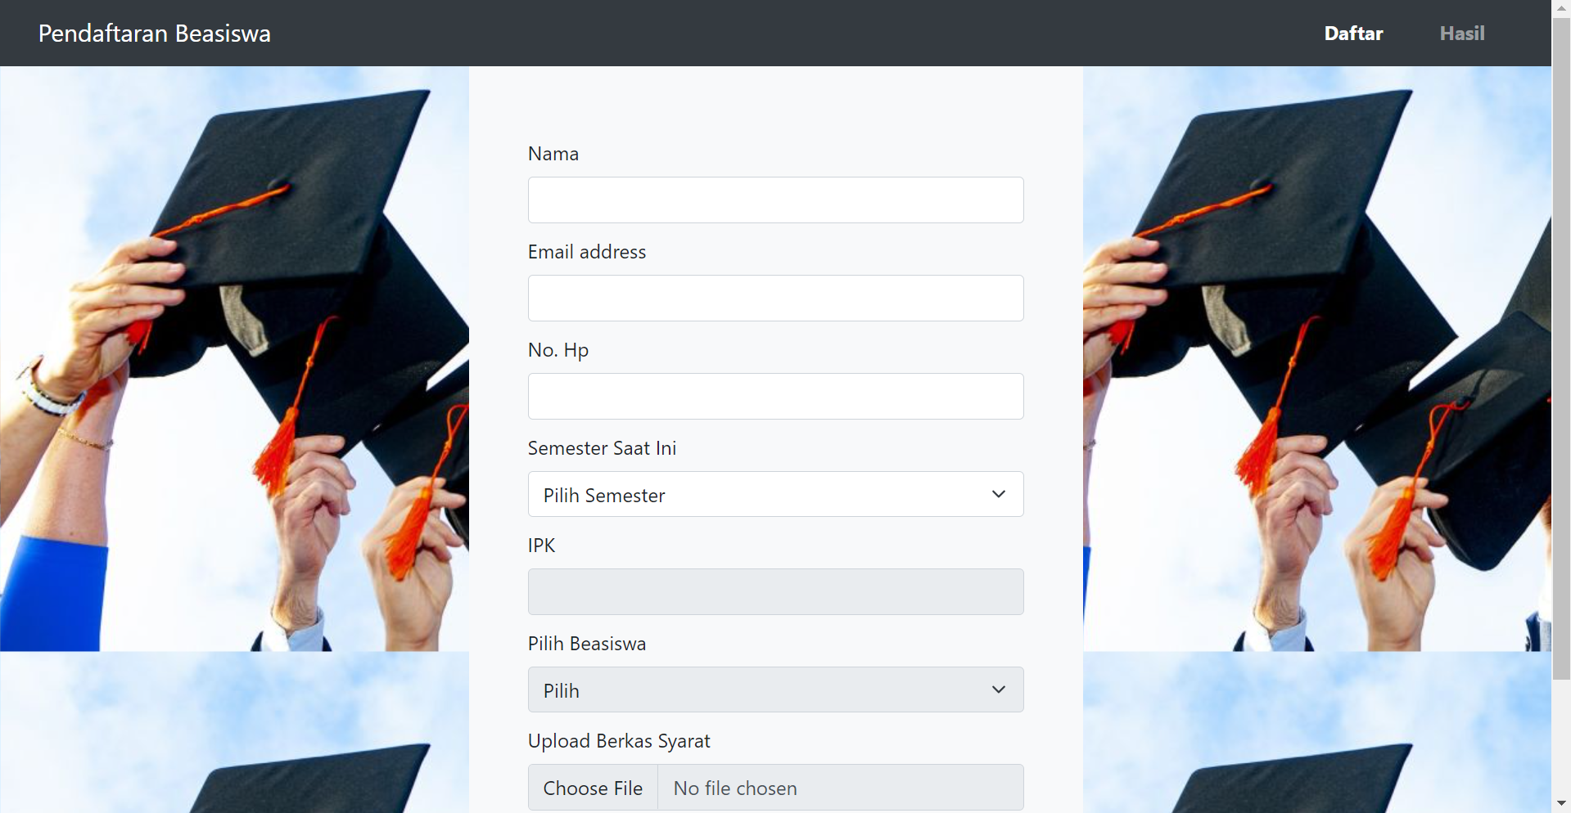

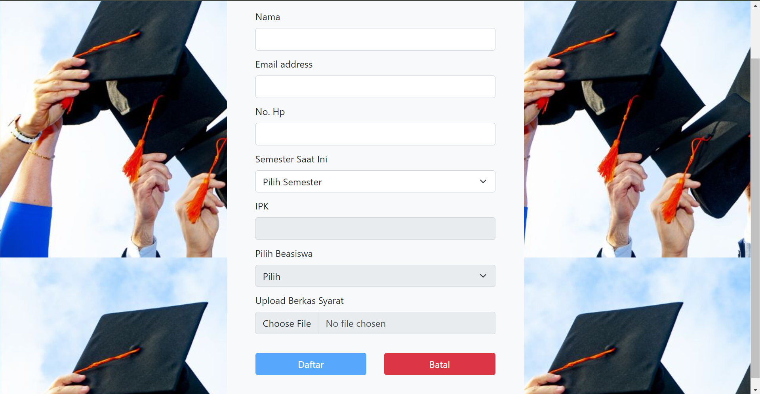

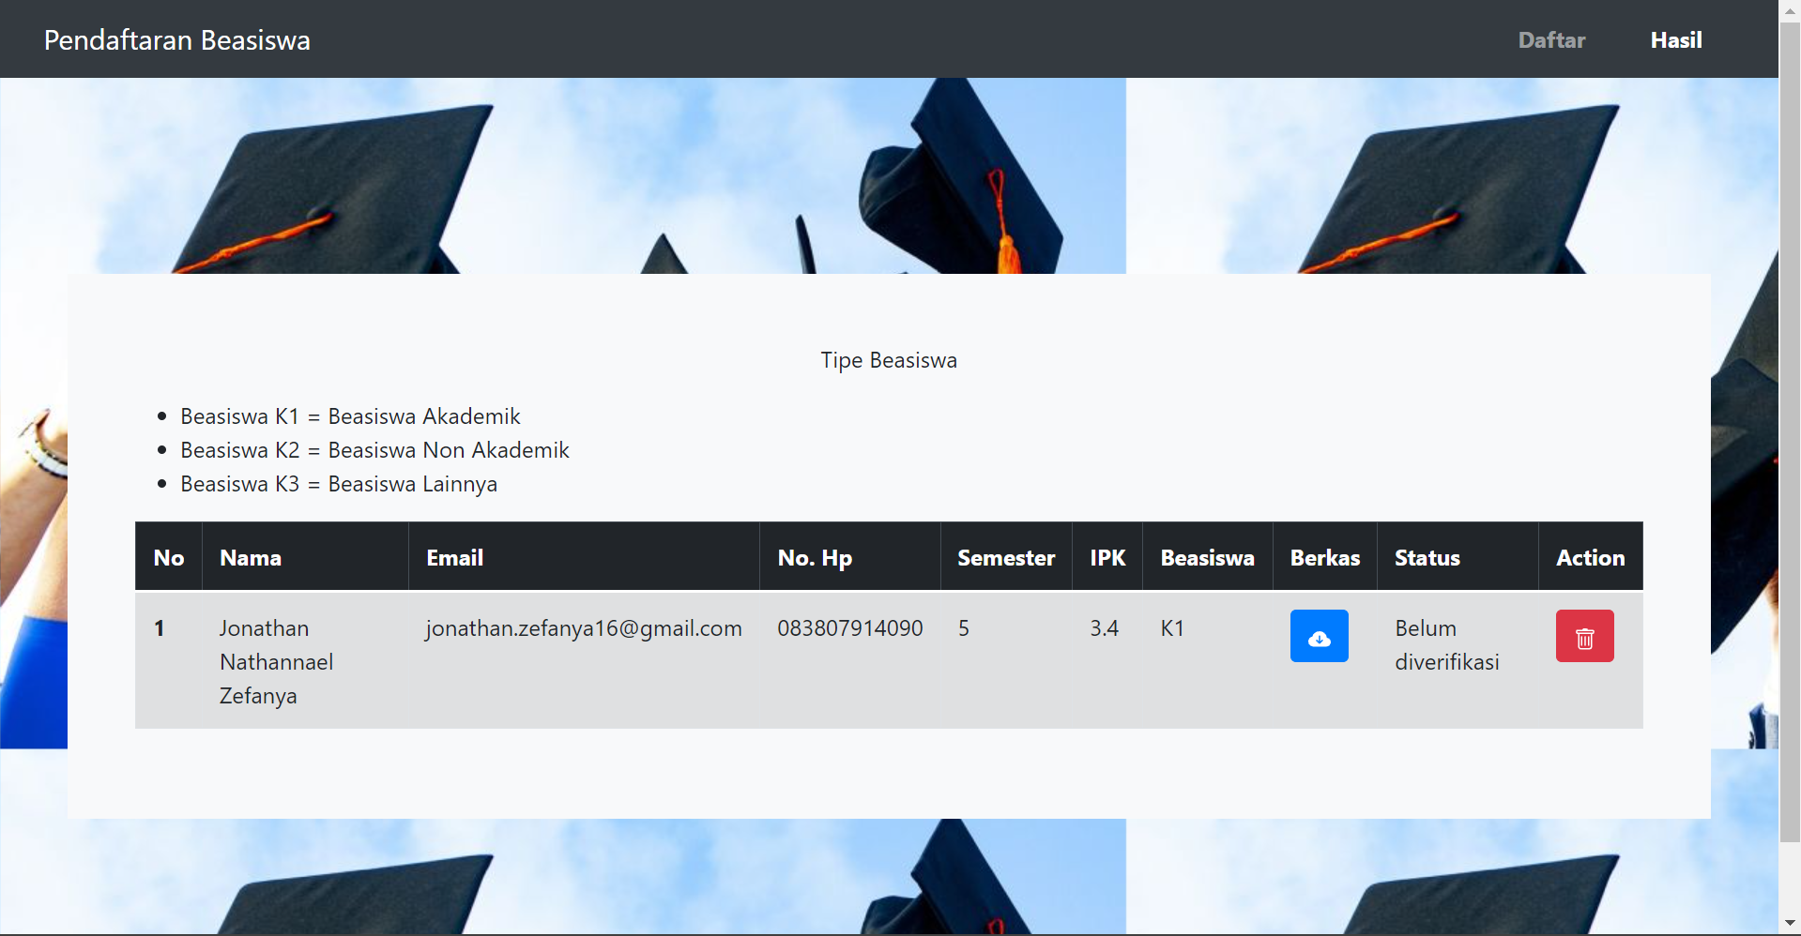

User Experince:

<https://drive.google.com/file/d/1uPUGLpF6vEvK4HF8HQSVlHo1MdMyzMdq/view?usp=sharing>

Source Code:

<https://github.com/JonathanZefanya/Beasiswa-Assesmen>